RDBMS LAB

**BCA-DS-552**

# Manav Rachna International Institute of Research and Studies School of Computer Applications

**Department of Computer Applications**

|  |  |
| --- | --- |
| **Submitted By** | |
| **Student Name** | **Shivam Thakur** |
| **Roll No** | **22/FCA/BCA/181** |
| **Program** | **Bachelor of Computer Applications** |
| **Semester** | **5th Semester** |
| **Section** | **B** |
| **Department** | **Computer Applications** |
| **Batch** | **2022-25** |
|  | |
| **Submitted To** | |
| **Faculty Name** | Mrs.Shilpa Bhatia & Mrs.Shruti Gupta |

|  |  |
| --- | --- |
|  | **SCHOOL OF**  **COMPUTER APPLICATIONS** |
| **Manav Rachna Campus Rd, Gadakhor Basti Village, Sector 43, Faridabad, Haryana 121004** | |

**SCHOOL OF COMPUTER APPLICATIONS**

|  |  |  |  |  |
| --- | --- | --- | --- | --- |
| **Index** | | | | |
| **S.**  **No** | **Program** | **Date of Submission** | **Remarks** | **Signature** |
| 1. | Create the following tables Customer and Orders | 01/08/24 |  |  |
| 2. | Insert five records for each table | 02/08/24 |  |  |
| 3. | Customer_SID column in the ORDERS table is a foreign key pointing to the SID column in the CUSTOMER table. | 08/08/24 |  |  |
| 4. | Insert five records for both tables | 09/08/24 |  |  |
| 5. | List the details of the customers along with the amount. | 16/08/24 |  |  |
| 6. | List the customers whose names end with “s”. | 21/08/24 |  |  |
| 7. | List the orders where amount is between 21000 and 30000 | 23/08/24 |  |  |
| 8. | List the orders where amount is increased by 500 and replace with name “new amount”. | 28/08/24 |  |  |
| 9. | Display the order_id and total amount of orders | 30/08/24 |  |  |
| 10. | Calculate the total amount of orders that has more than 15000. | 04/09/24 |  |  |
| 11. | Display all the string functions used in SQL. | 06/09/24 |  |  |
| 12. | Create the following tables Student and Student1 | 13/09/24 |  |  |
| 13. | Display all the contents of student and student1 using union clause. | 16/09/24 |  |  |
| 14. | Find out the intersection of student and student1 tables. | 20/09/24 |  |  |
| 15. | Display the names of student and student1 tables using left, right ,inner and full join. | 23/09/24 |  |  |
| 16. | Write a PL/SQL block to calculate total salary of employee having employee number 100. | 27/09/24 |  |  |
| 17. | Write a PL/SQL code to find the greatest of three numbers. | 30/09/24 |  |  |
| 18. | Write a PL/SQL code to print the numbers from 1 to n. | 04/10/24 |  |  |
| 19. | Write a PL/SQL code to reverse a string using for loop. | 07/10/24 |  |  |
| 20 | Write a PL/SQL code to find the sum of n numbers. | 14/10/24 |  |  |

|  |  |  |  |  |
| --- | --- | --- | --- | --- |
| 21. | Consider a PL/SQL code to display the empno, ename, job of employees of department number 10. | 21/10/24 |  |  |
| 22. | Consider a PL/SQL code to display the employee number & name of top five highest paid employees. | 25/10/24 |  |  |
| 23. | Consider a PL/SQL procedure that accepts 2 numbers &  return addition, subtraction, multiplication & division of two numbers using stored procedure AND local procedure. | 04/11/24 |  |  |
| 24. | Consider a PL/SQL code that accepts 2 numbers & return addition, subtraction, multiplication & division of two numbers using stored functions and local function. | 08/11/24 |  |  |
| 25. | Write a PL/SQL block to show the use of NO_DATA FOUND exception. | 11/11/24 |  |  |
| 26. | Write a PL/SQL block to show the use of TOO_MANY ROWS exception. | 18/11/24 |  |  |
| 27. | Write a PL/SQL block to show the use of ZERO_DIVIDE exception. | 18/11/24 |  |  |
| 28. | To create a trigger on the emp table, which store the  empno& operation in the table auditor for each operation  i.e. Insert, Update & Delete. | 25/11/24 |  |  |
| 29. | To create a trigger so that no operation can be performed on emp table. | 25/11/24 |  |  |

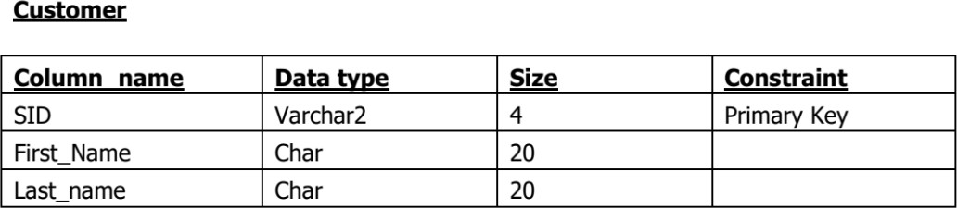

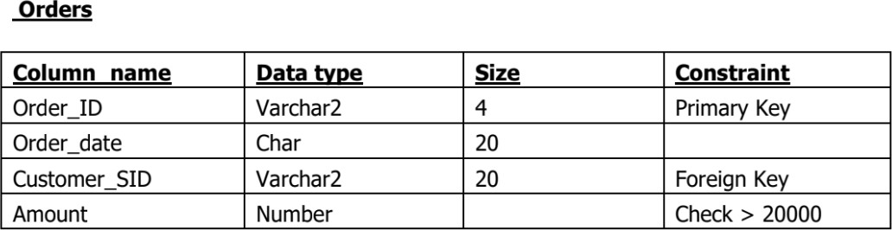

## Input

Create table Customers(

SID Varchar2(4) Primary key, First_Name Char(20), Last_Name Char(20)

);

Create table Orders(

Order_Id Varchar2(4) Primary key, Order_date Char(20), Customer_SID Varchar2(20), Amount Number,

CONSTRAINT fk_customer FOREIGN KEY (Customer_SID) REFERENCES Customer(SID),

CONSTRAINT chk_amount CHECK (Amount > 2000)

## Output

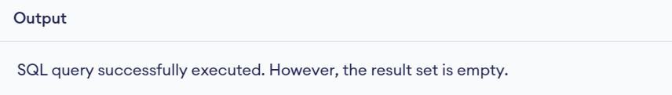

**Input**

INSERT INTO Customers (SID, First_Name, Last_Name) VALUES ('C1', 'John', 'Doe'); INSERT INTO Customers (SID, First_Name, Last_Name) VALUES ('C2', 'Robert', 'Luna'); INSERT INTO Customers (SID, First_Name, Last_Name) VALUES ('C3', 'David', 'Robinson'); INSERT INTO Customers (SID, First_Name, Last_Name) VALUES ('C4', 'Alice', 'Smith'); INSERT INTO Customers (SID, First_Name, Last_Name) VALUES ('C5', 'Betty', 'Doe');

INSERT INTO Orders (Order_Id, Order_date, Customer_SID, Amount) VALUES ('O1', '1 Sep', 'C1', 3000);

INSERT INTO Orders (Order_Id, Order_date, Customer_SID, Amount) VALUES ('O2', '2 Sep', 'C2', 4500),

INSERT INTO Orders (Order_Id, Order_date, Customer_SID, Amount) VALUES ('O3', '3 Sep', 'C3', 5000),

INSERT INTO Orders (Order_Id, Order_date, Customer_SID, Amount) VALUES ('O4', '4 Sep', 'C4', 6000),

INSERT INTO Orders (Order_Id, Order_date, Customer_SID, Amount) VALUES ('O5', '5 Sep', 'C5', 3500);

## Output

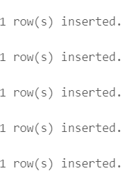

**Experiment 3:- Customer_SID column in the ORDERS table is a foreign key pointing to the SID column in the CUSTOMER table.**

This was already handled when the Orders table was created with a FOREIGN KEY constraint.

## Experiment No: 4

**Experiment 4:- Insert five records for both tables**

The records for both the Customer and Orders tables were inserted.

## Experiment No: 5

**Experiment 5:- List the details of the customers along with the amount. Input**

SELECT Customers.customer_id, Customers.first_name, Orders.amount FROM Customers

JOIN Orders ON Customers.customer_id = Orders.customer_id;

## Output

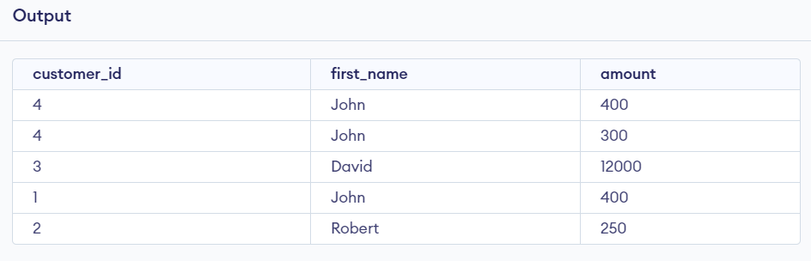

**Experiment 6:- List the customers whose names end with “s”. Input**

SELECT *

from Customers

where first_name like '%n';

## Output

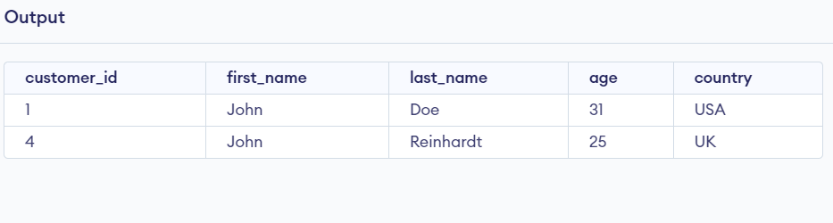

**Experiment No: 7**

## Experiment 7:- List the orders where amount is between 21000 and 30000 Input

SELECT *

from Orders

where amount between 400 and 12000;

## Output

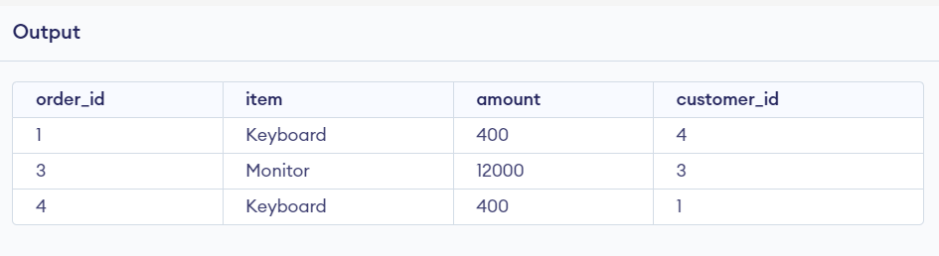

**Experiment 8:- List the orders where amount is increased by 500 and replace with name “new amount”.**

## Input

SELECT order_id, item,amount, amount + 500 AS "new amount" FROM Orders;

## Output

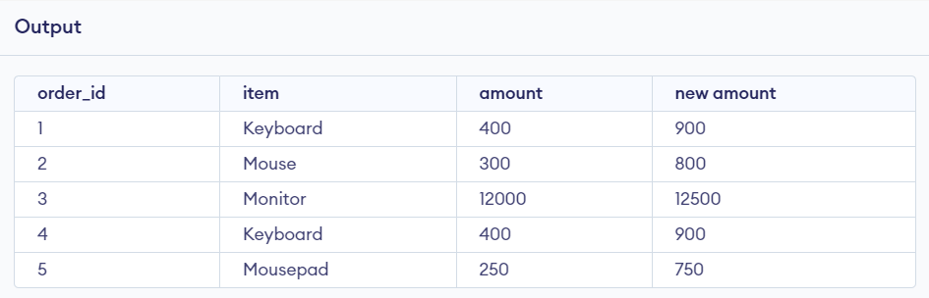

**Experiment No: 9**

## Experiment 8:- Display the order_id and total amount of orders. Input

SELECT customer_id, sum(amount) AS "total amount"

FROM Orders

group by customer_id

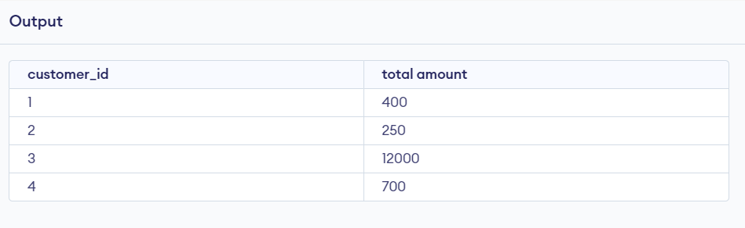

## Experiment 10:- Calculate the total amount of orders that has more than 15000.

**Input**

SELECT sum(amount) as total_amount FROM Orders

where amount>400;

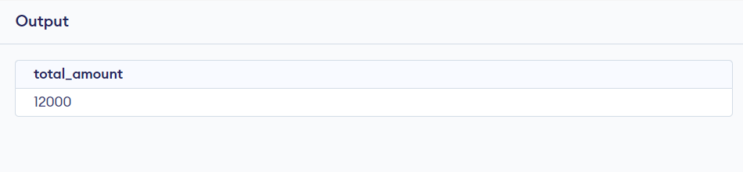

**Experiment No: 11**

# 11: Display all the string functions used in SQL.

UPPER(string) - Converts the string to uppercase. LOWER(string) - Converts the string to lowercase.

SUBSTR(string, start_position, length) - Extracts a substring. LENGTH(string)

- Returns the length of a string.

TRIM(string) - Removes spaces from both sides of the string. CONCAT(string1, string2) - Concatenates two strings.

REPLACE(string, search_string, replace_string) - Replaces occurrences of search string with replace string.

INSTR(string, substring) - Finds the position of a substring in a string.

# 12: Create the following tables.

CREATE TABLE Student (

RollNo VARCHAR2(20) PRIMARY KEY, Name CHAR(20), Class VARCHAR2(20), Marks NUMBER(6,2)

);

CREATE TABLE Student1 (

R_No VARCHAR2(20) PRIMARY KEY, Name CHAR(20),

Class VARCHAR2(20), Marks NUMBER(6,2)

);

INSERT INTO Student (RollNo, Name, Class, Marks) VALUES ('S001', 'Astitva', '10A', 85.50);

INSERT INTO Student (RollNo, Name, Class, Marks) VALUES ('S002', 'Ankita', '10B', 90.00);

INSERT INTO Student (RollNo, Name, Class, Marks) VALUES ('S003', 'Gunn', '10C', 75.75);

INSERT INTO Student (RollNo, Name, Class, Marks) VALUES ('S004', 'Laivish', '10A', 88.25);

INSERT INTO Student (RollNo, Name, Class, Marks) VALUES ('S005', 'Priya', '10B', 92.10);

INSERT INTO Student1 (R_No, Name, Class, Marks) VALUES ('S001', 'Astitva',

'10A', 85.50);

INSERT INTO Student1 (R_No, Name, Class, Marks) VALUES ('S002', 'Ankita',

'10B', 90.00);

INSERT INTO Student1 (R_No, Name, Class, Marks) VALUES ('S006', 'Megha',

'10C', 79.40);

INSERT INTO Student1 (R_No, Name, Class, Marks) VALUES ('S007', 'Pallavi',

'10A', 88.00);

INSERT INTO Student1 (R_No, Name, Class, Marks) VALUES ('S008', 'Krishna',

'10B', 91.50)

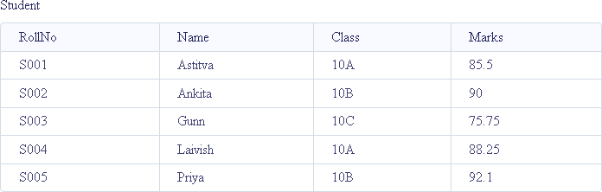

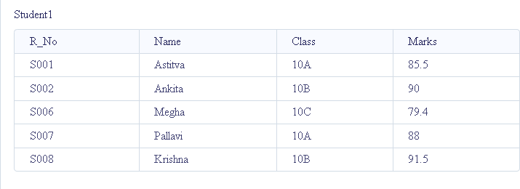

# 13: Display all the contents of student and student1 using union clause.

SELECT * FROM Student UNION

SELECT * FROM Student1;

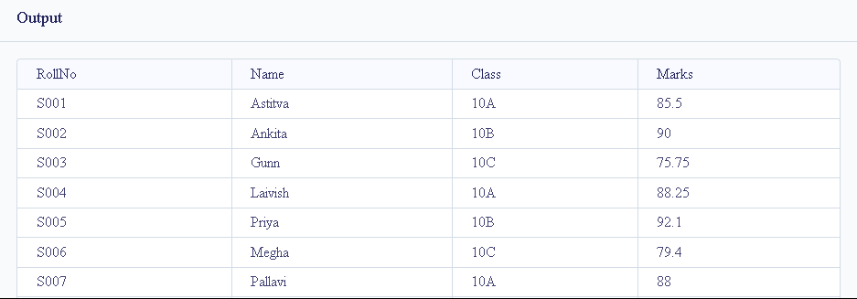

**Experiment No: 14**

# 14: Find out the intersection of student and student1 tables.

SELECT * FROM Student INTERSECT

SELECT * FROM Student1;

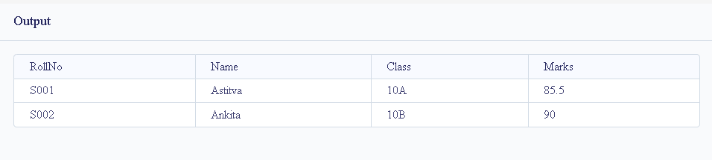

# 15: Display the names of student and student1 tables using left, right ,inner and full join.

SELECT Student.Name, Student1.Name FROM Student

LEFT JOIN Student1 ON Student.RollNo = Student1.R_No;

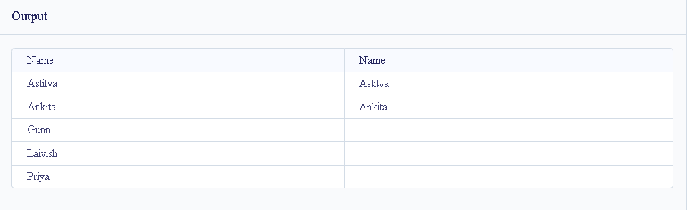

RIGHT and FULL OUTER JOINs are not currently supported. SELECT Student.Name, Student1.Name

FROM Student

INNER JOIN Student1 ON Student.RollNo = Student1.R_No;

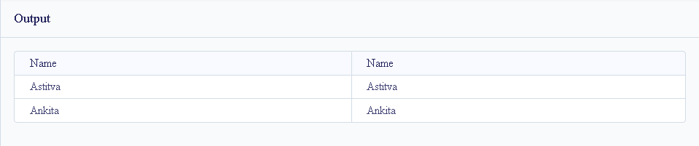

**Experiment 16:- Write a PL/SQL block to calculate total salary of employee having employee number 100.**

**Input**

Create table Customers( DECLARE emp_id NUMBER := 100;

emp_name VARCHAR2(50) := 'Ram';

base_salary NUMBER := 50000; -- Example base salary total_salary NUMBER;

BEGIN

-- Simulate calculation of total salary (for example, adding a bonus) total_salary := base_salary + (base_salary * 0.10); -- Adding 10% bonus

-- Display the total salary DBMS_OUTPUT.PUT_LINE('Employee ID: ' || emp_id); DBMS_OUTPUT.PUT_LINE('Employee Name: ' || emp_name); DBMS_OUTPUT.PUT_LINE('Total Salary: ' || total_salary);

END;

/

## Output

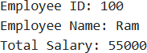

**Experiment 17:- Write a PL/SQL code to find the greatest of three numbers.**

## Input

DECLARE

num1 NUMBER := 25; num2 NUMBER := 75; num3 NUMBER := 50;

greatest NUMBER; BEGIN

-- Compare the three numbers to find the greatest IF (num1 >= num2) AND (num1 >= num3) THEN

greatest := num1;

ELSIF (num2 >= num1) AND (num2 >= num3) THEN greatest := num2;

ELSE

greatest := num3; END IF;

-- Display the greatest number

DBMS_OUTPUT.PUT_LINE('The greatest number is: ' || greatest); END;

/

## Output



**Experiment 18:- Write a PL/SQL code to print the numbers from 1 to n. Input**

DECLARE

n NUMBER := 10; -- Set the value of n here i NUMBER := 1; -- Initialize the counter

BEGIN

WHILE i <= n LOOP DBMS_OUTPUT.PUT_LINE(i);

i := i + 1; -- Increment the counter END LOOP;

END;

/

## Output



**Experiment 19:- Write a PL/SQL code to reverse a string using for loop. Input**

DECLARE

original_string VARCHAR2(100) := 'Hello World'; -- Input string to reverse reversed_string VARCHAR2(100) := '';

BEGIN

-- Loop through the original string in reverse order

FOR i IN REVERSE 1..LENGTH(original_string) LOOP reversed_string := reversed_string || SUBSTR(original_string, i, 1);

END LOOP;

-- Display the reversed string DBMS_OUTPUT.PUT_LINE('Original String: ' || original_string); DBMS_OUTPUT.PUT_LINE('Reversed String: ' || reversed_string);

END;

/

## Output



**Experiment 20:- Write a PL/SQL code to find the sum of n numbers. Input**

DECLARE

n NUMBER := 10; -- Set the value of n here sum NUMBER := 0; -- Initialize the sum to 0

BEGIN

FOR i IN 1..n LOOP

sum := sum + i; -- Add each number from 1 to n END LOOP;

-- Display the result

DBMS_OUTPUT.PUT_LINE('The sum of numbers from 1 to ' || n || ' is: ' || sum); END;

/

## Output



**Experiment 21:- Consider a PL/SQL code to display the empno, ename, job of employees of department number 10.**

## Input

DECLARE

TYPE emp_record IS RECORD ( empno NUMBER,

ename VARCHAR2(50), job VARCHAR2(50),

deptno NUMBER );

TYPE emp_table IS TABLE OF emp_record INDEX BY PLS_INTEGER; employees emp_table;

BEGIN

employees(1) := emp_record(1001, 'John Doe', 'Manager', 10); employees(2) := emp_record(1002, 'Jane Smith', 'Analyst', 20); employees(3) := emp_record(1003, 'Bob Johnson', 'Clerk', 10); employees(4) := emp_record(1004, 'Alice Davis', 'Developer', 30); employees(5) := emp_record(1005, 'Charlie Brown', 'Analyst', 10); DBMS_OUTPUT.PUT_LINE('EMPNO | ENAME | JOB'); DBMS_OUTPUT.PUT_LINE(' ');

FOR i IN employees.FIRST .. employees.LAST LOOP IF employees(i).deptno = 10 THEN

DBMS_OUTPUT.PUT_LINE(employees(i).empno || ' | ' || employees(i).ename || ' | ' || employees(i).job);

END IF;

END LOOP;

END; /

## Output

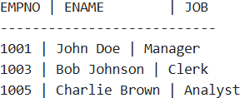

**Experiment 22:- Consider a PL/SQL code to display the employee number & name of top five highest paid employees.**

## Input

DECLARE

-- Define a PL/SQL table type to hold employee records TYPE emp_record IS RECORD (

empno NUMBER, ename VARCHAR2(50),

salary NUMBER

);

TYPE emp_table IS TABLE OF emp_record INDEX BY PLS_INTEGER; employees emp_table;

-- Variable to store sorted employees sorted_employees emp_table;

BEGIN

-- Populate the table with sample data

employees(1) := emp_record(1001, 'John Doe', 90000); employees(2) := emp_record(1002, 'Jane Smith', 75000); employees(3) := emp_record(1003, 'Bob Johnson', 60000); employees(4) := emp_record(1004, 'Alice Davis', 95000); employees(5) := emp_record(1005, 'Charlie Brown', 85000); employees(6) := emp_record(1006, 'Emma White', 70000); employees(7) := emp_record(1007, 'Liam Green', 65000);

-- Sort the employees based on salary (simple bubble sort) DECLARE

i PLS_INTEGER; j PLS_INTEGER;

temp emp_record; BEGIN

FOR i IN employees.FIRST .. employees.LAST LOOP FOR j IN i + 1 .. employees.LAST LOOP

IF employees(i).salary < employees(j).salary THEN temp := employees(i);

employees(i) := employees(j); employees(j) := temp;

END IF; END LOOP;

END LOOP;

-- Store the top 5 in sorted_employees FOR i IN 1 .. 5 LOOP

sorted_employees(i) := employees(i); END LOOP;

END;

-- Display the top 5 highest paid employees DBMS_OUTPUT.PUT_LINE('EMPNO | ENAME | SALARY'); DBMS_OUTPUT.PUT_LINE(' ');

FOR i IN sorted_employees.FIRST .. sorted_employees.LAST LOOP DBMS_OUTPUT.PUT_LINE(sorted_employees(i).empno || ' | ' ||

sorted_employees(i).ename || ' | ' || sorted_employees(i).salary);

END LOOP;

END;

## Output

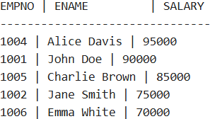

**Experiment No: 23**

## Experiment 23:- Consider a PL/SQL procedure that accepts 2 numbers & return addition, subtraction, multiplication & division of two numbers using stored procedure AND local procedure.

**Input**

CREATE OR REPLACE PROCEDURE calculate_operations ( num1 IN NUMBER,

num2 IN NUMBER

) IS

PROCEDURE local_operations ( a IN NUMBER,

b IN NUMBER

) IS

add_result NUMBER; sub_result NUMBER; mul_result NUMBER; div_result NUMBER;

BEGIN

-- Perform calculations add_result := a + b; sub_result := a - b; mul_result := a * b;

-- Check for division by zero IF b != 0 THEN

div_result := a / b; ELSE

div_result := NULL; -- Division not possible END IF;

-- Display results DBMS_OUTPUT.PUT_LINE('Addition: ' || add_result); DBMS_OUTPUT.PUT_LINE('Subtraction: ' || sub_result);

DBMS_OUTPUT.PUT_LINE('Multiplication: ' || mul_result); IF div_result IS NOT NULL THEN

DBMS_OUTPUT.PUT_LINE('Division: ' || div_result); ELSE

DBMS_OUTPUT.PUT_LINE('Division: Not Possible (Division by Zero)'); END IF;

END local_operations; BEGIN

-- Call local procedure local_operations(num1, num2);

END calculate_operations;

/

BEGIN

calculate_operations(10, 5); -- Example with valid inputs calculate_operations(8, 0); -- Example to test division by zero

END;

/

## Output

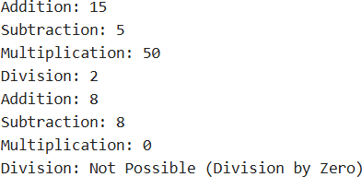

**Experiment 24:- Consider a PL/SQL code that accepts 2 numbers & return addition, subtraction, multiplication & division of two numbers using**

## stored functions and local function. Input

SET SERVEROUTPUT ON; -- Stored Function

CREATE OR REPLACE FUNCTION perform_operations(num1 IN NUMBER, num2 IN NUMBER) RETURN VARCHAR2

IS -- Local Function for Division

FUNCTION divide_numbers(a IN NUMBER, b IN NUMBER) RETURN VARCHAR2 IS BEGIN

IF b != 0 THEN

RETURN TO_CHAR(a / b); -- Convert division result to string ELSE

RETURN 'Not Possible (Division by Zero)'; -- Handle division by zero END IF; END divide_numbers;

BEGIN

RETURN 'Addition: ' || TO_CHAR(num1 + num2) || ', ' || 'Subtraction: ' || TO_CHAR(num1 - num2) || ', ' || 'Multiplication: ' || TO_CHAR(num1 * num2) || ', ' || 'Division: ' || divide_numbers(num1, num2);

END perform_operations; /

DECLARE -- Anonymous Block to Call the Function result VARCHAR2(500);

BEGIN

result := perform_operations(10, 5); -- Call with valid inputs DBMS_OUTPUT.PUT_LINE(result);

result := perform_operations(8, 0); -- Call with division by zero DBMS_OUTPUT.PUT_LINE(result);

END; /

## Output



**Experiment 25:- Write a PL/SQL block to show the use of NO_DATA FOUND exception.**

## Input

CREATE TABLE emp (

empno NUMBER PRIMARY KEY, ename VARCHAR2(100) );

-- Insert sample data

INSERT INTO emp (empno, ename) VALUES (1001, 'John Doe'); INSERT INTO emp (empno, ename) VALUES (1002, 'Jane Smith'); COMMIT;

SET SERVEROUTPUT ON; BEGIN

-- Declare variables DECLARE

v_employee_name VARCHAR2(100); BEGIN

-- Attempt to fetch an employee name for a non-existent employee ID SELECT ename

INTO v_employee_name FROM emp

WHERE empno = 9999; -- This employee ID does not exist

-- If no exception occurs, display the employee name DBMS_OUTPUT.PUT_LINE('Employee Name: ' || v_employee_name);

EXCEPTION

WHEN NO_DATA_FOUND THEN -- Handle the exception DBMS_OUTPUT.PUT_LINE('No employee found with the given ID.');

END; END;

## Output



**Experiment 26:- Write a PL/SQL block to show the use of TOO_MANY ROWS exception.**

## Input

-- Create a sample table CREATE TABLE emp (

empno NUMBER PRIMARY KEY, ename VARCHAR2(100),

deptno NUMBER

);

-- Insert sample data

INSERT INTO emp (empno, ename, deptno) VALUES (1001, 'John Doe', 10); INSERT INTO emp (empno, ename, deptno) VALUES (1002, 'Jane Smith', 10); INSERT INTO emp (empno, ename, deptno) VALUES (1003, 'Alice Brown', 20); COMMIT;

-- PL/SQL block to demonstrate TOO_MANY_ROWS exception SET SERVEROUTPUT ON;

BEGIN

-- Declare variables DECLARE

v_employee_name VARCHAR2(100); BEGIN

-- Attempt to fetch an employee name where multiple rows exist SELECT ename

INTO v_employee_name FROM emp

WHERE deptno = 10; -- More than one employee in department 10

-- If no exception occurs, display the employee name DBMS_OUTPUT.PUT_LINE('Employee Name: ' || v_employee_name);

EXCEPTION

WHEN TOO_MANY_ROWS THEN

-- Handle the exception

DBMS_OUTPUT.PUT_LINE('Error: Query returned more than one row.'); END;

END;

/

## Output



**Experiment No: 27**

## Experiment 27:- Write a PL/SQL block to show the use of ZERO_DIVIDE exception.

**Input**

SET SERVEROUTPUT ON; BEGIN

DECLARE

num1 NUMBER := 10; num2 NUMBER := 0;

result NUMBER; BEGIN

result := num1 / num2; -- Attempt division by zero DBMS_OUTPUT.PUT_LINE('Result: ' || result);

EXCEPTION

WHEN ZERO_DIVIDE THEN

DBMS_OUTPUT.PUT_LINE('Error: Division by zero is not allowed.'); END;

END;

/

## Output



**Experiment No: 28**

## Experiment 28:- To create a trigger on the emp table, which store the empno& operation in the table auditor for each operation i.e. Insert, Update & Delete.exception.

**Input**

-- Create the employee table (emp) CREATE TABLE emp (

empno NUMBER PRIMARY KEY, ename VARCHAR2(50),

job VARCHAR2(50)

);

-- Create the auditor table to store operations CREATE TABLE auditor (

audit_id NUMBER GENERATED BY DEFAULT AS IDENTITY PRIMARY KEY,

empno NUMBER, operation_type VARCHAR2(10),

operation_date TIMESTAMP DEFAULT CURRENT_TIMESTAMP

);

-- Create a trigger to log INSERT operations

CREATE OR REPLACE TRIGGER emp_audit_trigger AFTER INSERT OR UPDATE OR DELETE

ON emp

FOR EACH ROW BEGIN

-- Insert log into the auditor table IF INSERTING THEN

INSERT INTO auditor (empno, operation_type) VALUES (:NEW.empno, 'INSERT');

ELSIF UPDATING THEN

INSERT INTO auditor (empno, operation_type) VALUES (:NEW.empno, 'UPDATE');

ELSIF DELETING THEN

INSERT INTO auditor (empno, operation_type) VALUES (:OLD.empno, 'DELETE');

END IF;

END;

/

-- Insert a new employee

INSERT INTO emp (empno, ename, job) VALUES (101, 'John Doe', 'Manager');

-- Update an employee

UPDATE emp SET ename = 'Johnathan Doe' WHERE empno = 101;

-- Delete an employee

DELETE FROM emp WHERE empno = 101;

-- Check the auditor table for logged operations SELECT * FROM auditor;

## Output

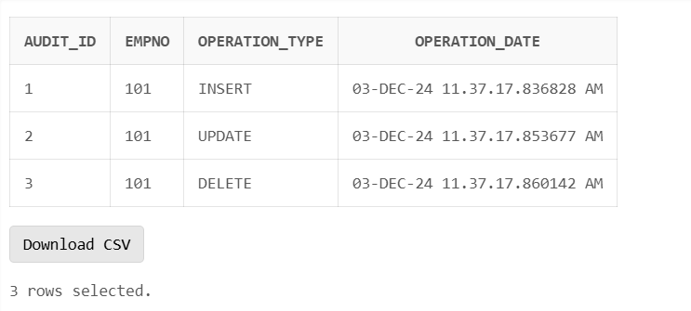

**Experiment No: 29**

## Experiment 29:- To create a trigger so that no operation can be performed on emp table.

**Input**

-- Create the trigger to prevent all operations on the emp table CREATE OR REPLACE TRIGGER prevent_emp_operations BEFORE INSERT OR UPDATE OR DELETE

ON emp BEGIN

-- Raise an exception to prevent the operation

RAISE_APPLICATION_ERROR(-20001, 'Operations on the emp table are not allowed.'); END;

/

-- Trying to insert a new employee (this will fail)

INSERT INTO emp (empno, ename, job) VALUES (101, 'John Doe', 'Manager');

-- Trying to update an employee (this will fail)

UPDATE emp SET ename = 'Jane Doe' WHERE empno = 101;

-- Trying to delete an employee (this will fail) DELETE FROM emp WHERE empno = 101;

## Output

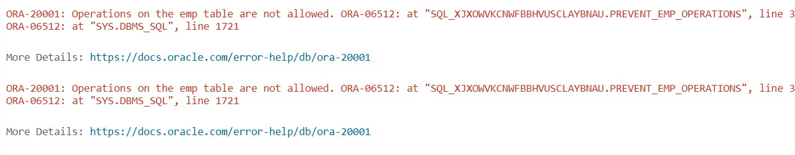

**Conclusion:**

This trigger will effectively prevent any operation (INSERT, UPDATE, DELETE) from being performed on the emp table by raising an exception.